Medical Insurance

Python.file:

Screenshot:

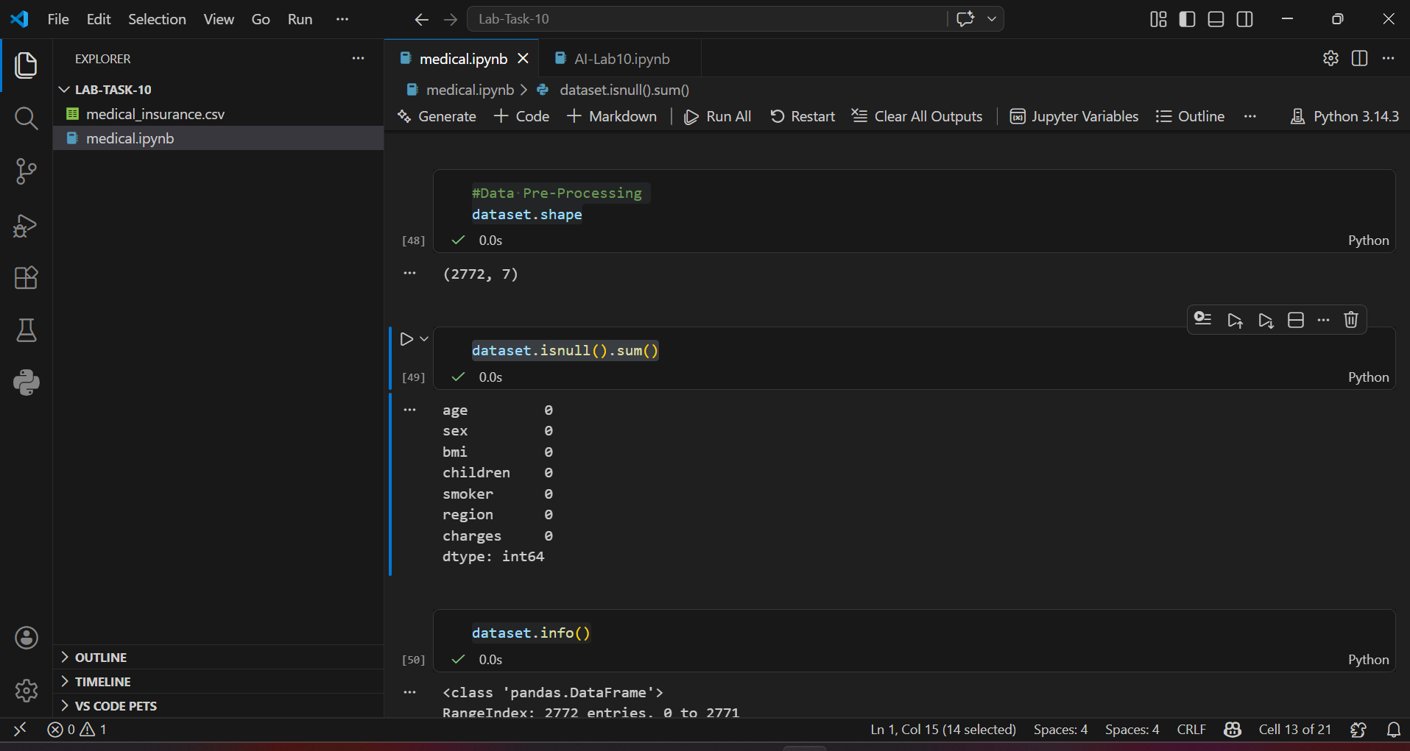

CSV File:

Details:

1. Importing Libraries
We imported necessary libraries such as Pandas and NumPy to handle and process the dataset.
import pandas as pd
import numpy as np

2. Loading the Dataset
The dataset was loaded using Pandas:
dataset = pd.read_csv("medical_insurance.csv")

3. Exploring the Dataset
We explored the dataset using different functions:
- dataset.head() → to view first 5 rows
- dataset.tail() → to view last 5 rows
- dataset.shape → to check number of rows and columns
- dataset.columns → to display column names
- dataset.info() → to get dataset summary
- dataset.describe() → to get statistical summary

4. Checking Null Values
We checked missing (null) values in the dataset:
dataset.isnull().sum()

5. Handling Null Values
We handled missing values by filling them with the mean (average) of their respective columns.
columns = ['bmi', 'children', 'charges']
for col in columns:
dataset[col] = dataset[col].fillna(dataset[col].mean())
This ensures no missing data remains in important columns.

6. Changing Data Types
We converted column data types to integer for better processing:
dataset['children'] = dataset['children'].astype(int)
dataset['charges'] = dataset['charges'].astype(int)
dataset['bmi'] = dataset['bmi'].astype(int)

7. Saving the Cleaned Dataset
After preprocessing, we saved the cleaned dataset:
dataset.to_csv('medical_insurance_cleaned.csv', index=False)

8. Splitting Features and Target Variable
We separated the independent variables (features) and dependent variable (target):
X = data.drop('charges', axis=1)
y = data['charges']
- X contains all input features like age, sex, bmi, children, smoker, and region
- y contains the target variable (insurance charges)

9. Encoding Categorical Data
Since machine learning models cannot process text data directly, we converted categorical columns into numerical values using Label Encoding:
from sklearn.preprocessing import LabelEncoder
le = LabelEncoder()
X['sex'] = le.fit_transform(X['sex'])
X['smoker'] = le.fit_transform(X['smoker'])
X['region'] = le.fit_transform(X['region'])
- Converts categories like male/female, yes/no, and regions into numbers

10. Polynomial Feature Transformation
We applied Polynomial Features to increase model complexity and capture non-linear relationships:
from sklearn.preprocessing import PolynomialFeatures
poly = PolynomialFeatures(degree=2)
X = poly.fit_transform(X)
- Degree 2 creates interaction features (e.g., age², bmi×age)

11. Train-Test Split
We split the dataset into training and testing sets:
from sklearn.model_selection import train_test_split
train_X, test_X, train_y, test_y = train_test_split(X, y, test_size=0.2, shuffle=False)
- 80% data used for training
- 20% data used for testing
- shuffle=False keeps data order unchanged

12. Model Training
We trained the model using Linear Regression:
from sklearn.linear_model import LinearRegression
model = LinearRegression()
model.fit(train_X, train_y)

13. Making Predictions
After training, we predicted values on test data:
predictions = model.predict(test_X)

14. Model Evaluation (R2 Score)
We evaluated model performance using R² Score:
from sklearn.metrics import r2_score
r2 = r2_score(test_y, predictions)
print("R2 Score:", r2)
- R² Score measures how well the model fits the data
- Value ranges from 0 to 1
  - 1 = perfect prediction
  - 0 = poor model

